Министерство образования и науки РФ

Федеральное государственное автономное
образовательное учреждение высшего образования
«Санкт-Петербургский национальный исследовательский университет
ИТМО»

Лабораторная работа №1
по дисциплине “Базы Данных”
Вариант №466298

Студент:
Корхонен Артём Андреевич
Преподаватель:
Гиря Максим Дмитриевич

Санкт-Петербург
2024
Текст задания
Для выполнения лабораторной работы №1 необходимо:
- На основе предложенной предметной области (текста) составить ее описание. Из полученного описания выделить сущности, их атрибуты и связи.
- Составить инфологическую модель.
- Составить даталогическую модель. При описании типов данных для атрибутов должны использоваться типы из СУБД PostgreSQL.
- Реализовать даталогическую модель в PostgreSQL. При описании и реализации даталогической модели должны учитываться ограничения целостности, которые характерны для полученной предметной области.
- Заполнить созданные таблицы тестовыми данными.

Описание предметной области, по которой должна быть построена доменная модель:
Грант удивленно огляделся. Они оказались в небольшом помещении размером с маленькую кладовку. Все было заставлено какой-то техникой: неподвижными насосами, большими фильтрами с толстыми трубами. Все было холодным и мокрым.

Инфологическая модель
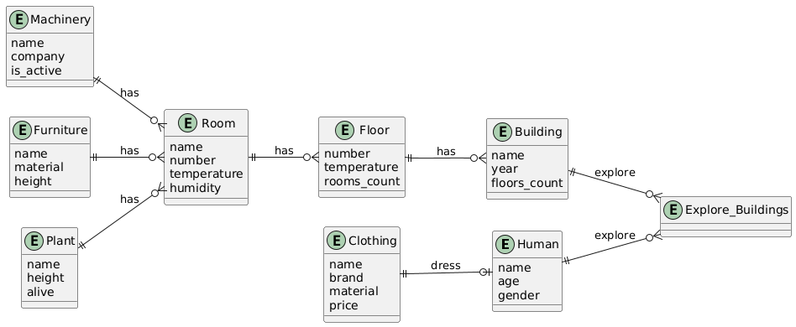
Даталогическая модель
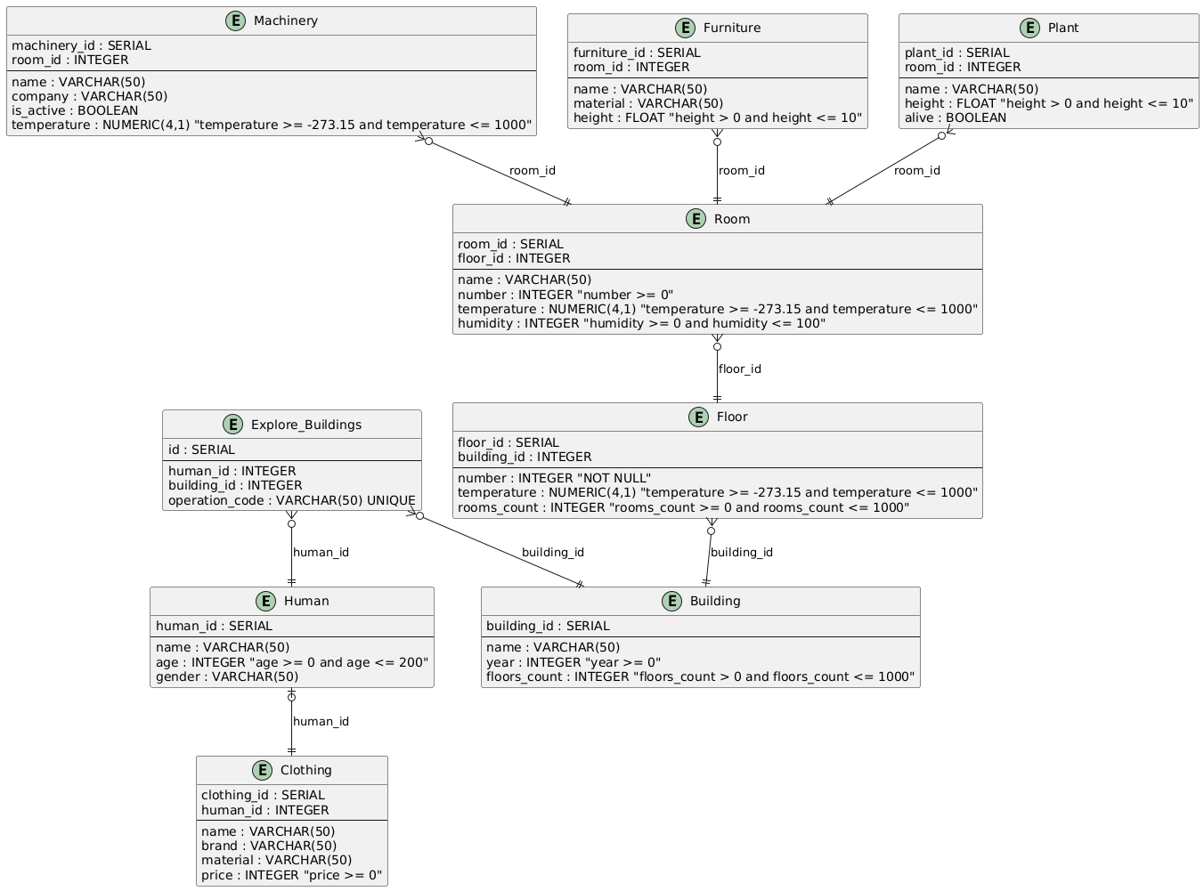

Создание таблиц
CREATE TABLE Human (
human_id SERIAL PRIMARY KEY,
name VARCHAR(50) NOT NULL,
age INTEGER CHECK (age >= 0 AND age <= 200),
gender VARCHAR(50) NOT NULL
);

CREATE TABLE Clothing (
clothing_id SERIAL PRIMARY KEY,
human_id INTEGER REFERENCES Human(human_id) ON DELETE CASCADE,
name VARCHAR(50) NOT NULL,
brand VARCHAR(50) NOT NULL,
material VARCHAR(50) NOT NULL,
price INTEGER CHECK (price >= 0)
);

CREATE TABLE Building (
building_id SERIAL PRIMARY KEY,
name VARCHAR(50) NOT NULL,
year INTEGER CHECK (year >= 0),
floors_count INTEGER CHECK (floors_count > 0 AND floors_count <= 1000)
);

CREATE TABLE Explore_Buildings (
id SERIAL PRIMARY KEY,
human_id INTEGER REFERENCES Human(human_id) ON DELETE CASCADE,
building_id INTEGER REFERENCES Building(building_id) ON DELETE CASCADE,
operation_code VARCHAR(50) NOT NULL UNIQUE
);

CREATE TABLE Floor (
floor_id SERIAL PRIMARY KEY,
building_id INTEGER REFERENCES Building(building_id) ON DELETE CASCADE,
number INTEGER CHECK (number >= 0),
temperature NUMERIC(4,1) CHECK (temperature >= -273.15 AND temperature <= 1000),
rooms_count INTEGER CHECK (rooms_count >= 0 AND rooms_count <= 1000)
);

CREATE TABLE Room (
room_id SERIAL PRIMARY KEY,
floor_id INTEGER REFERENCES Floor(floor_id) ON DELETE CASCADE,
name VARCHAR(50) NOT NULL,
number INTEGER CHECK (number >= 0),
temperature NUMERIC(4,1) CHECK (temperature >= -273.15 AND temperature <= 1000),
humidity INTEGER CHECK (humidity >= 0 AND humidity <= 100)
);

CREATE TABLE Machinery (
machinery_id SERIAL PRIMARY KEY,
room_id INTEGER REFERENCES Room(room_id) ON DELETE CASCADE,
name VARCHAR(50) NOT NULL,
company VARCHAR(50) NOT NULL,
is_active BOOLEAN
);

CREATE TABLE Furniture (
furniture_id SERIAL PRIMARY KEY,
room_id INTEGER REFERENCES Room(room_id) ON DELETE CASCADE,
name VARCHAR(50) NOT NULL,
material VARCHAR(50) NOT NULL,
height FLOAT CHECK (height > 0 AND height <= 10)
);

CREATE TABLE Plant (
plant_id SERIAL PRIMARY KEY,
room_id INTEGER REFERENCES Room(room_id) ON DELETE CASCADE,
name VARCHAR(50) NOT NULL,
height FLOAT CHECK (height > 0 AND height <= 10),
alive BOOLEAN
);

Заполнение таблиц
INSERT INTO Human (name, age, gender) VALUES
("Alice", 22, "Female"),
("Jack", 21, "Male"),
("Tom", 22, "Male");

INSERT INTO Clothing (human_id, name, brand, material, price) VALUES
(1, "Sweatshirt", "Sweet Company", "Cotton", 2999),
(1, "Jeans", "Sweet Company", "Denim", 1899),
(1, "Sneakers", "Sports Attack", "Textile", 7999),
(2, "Cap", "Caps Masters", "Cotton", 1500),
(2, "T-Shirt", "DinoPark Merch", "Cotton", 999),
(2, "Sport Pants", "Sports Attack", "Stretch", 3499),
(2, "Sneakers", "Low Price Shop", "Textile", 800),
(3, "T-Shirt", "Official Style Company", "Cotton", 2899),
(3, "Shirt", "Official Style Company", "Cotton", 6999),
(3, "Jacket", "Official Style Company", "Wool", 11999),
(3, "Trousers", "Official Style Company", "Flax", 7999),
(3, "Shoes", "Official Style Company", "Genuine leather", 39999);

INSERT INTO Building (name, year, floors_count) VALUES
("Small Office", 1979, 2),
("Small Office", 1987, 2),
("Cottage", 1898, 1);

INSERT INTO Explore_Buildings (human_id, building_id, operation_code) VALUES
(1, 1, "ca5525fa-5ad8-44ad-8090-6efa2a76e9d1"),
(1, 2, "60756d2d-e915-41ae-81d0-d8b97121d745"),
(2, 3, "73023522-2efb-48e5-b9f6-601a6172c7ff"),
(3, 1, "530b46c9-143b-402a-a4a0-c65362133d82"),
(3, 3, "8ee8bf3f-4680-4f1f-9b90-f5ea615d0ce7");

INSERT INTO Floor (building_id, number, temperature, rooms_count) VALUES
(1, 1, 22, 2),
(1, 2, 22, 2),
(2, 1, 13, 2),
(2, 2, 11, 2),
(3, 1, 23, 2);

INSERT INTO Room (floor_id, name, number, temperature, humidity) VALUES
(1, "Office room 1", 11, 23, 48),
(1, "Office room 2", 12, 22, 47),
(2, "Office room 3", 21, 22, 47),
(2, "Director room", 22, 22, 48),
(3, "Office room 1", 1, 12, 73),
(3, "Office room 2", 2, 12, 73),
(4, "Office room 3", 3, 10, 74),
(4, "Director room", 4, 11, 76),
(5, "Kitchen / Living Room", 0, 23, 37),
(5, "Bedroom", 0, 23, 37);

INSERT INTO Machinery (room_id, name, company, is_active) VALUES
(1, "Computer", "PacBook", TRUE),
(1, "Printer", "Paper Lovers", TRUE),
(2, "Computer", "PacBook", TRUE),
(2, "Laptop", "PacBook", FALSE),
(2, "Printer", "Paper Lovers", FALSE),
(3, "Computer", "PacBook", FALSE),
(3, "Printer", "Paper Lovers", TRUE),
(4, "Computer", "PacBook", TRUE),
(4, "Laptop", "Premium PC", TRUE),
(4, "Printer", "Paper Lovers", TRUE),
(5, "Computer", "BomPC", FALSE),
(5, "Printer", "Office Scan Systems", FALSE),
(6, "Computer", "BomPC", FALSE),
(6, "Printer", "Office Scan Systems", FALSE),
(7, "Computer", "BomPC", FALSE),
(7, "Printer", "Office Scan Systems", FALSE),
(8, "Computer", "BomPC", FALSE),
(8, "Computer", "PacBook", FALSE),
(8, "Laptop", "PickMeBook", FALSE),
(8, "Printer", "Office Scan Systems", FALSE),
(9, "Microwave", "SMS Kitchen Inc.", TRUE),
(9, "Fridge", "SMS Kitchen Inc.", TRUE),
(9, "Multicooker", "SMS Kitchen Inc.", TRUE),
(10, "Lamp", "My love is book", FALSE),
(10, "Lamp", "Light Life", TRUE);

INSERT INTO Furniture (room_id, name, material, height) VALUES
(1, "Table", "Wood", 0.8),
(1, "Bookshelf", "Wood", 2.5),
(2, "Table", "Wood", 0.8),
(2, "Bookshelf", "Wood", 2.5),
(3, "Table", "Wood", 0.8),
(3, "Bookshelf", "Wood", 2.5),
(4, "Table", "Wood", 0.8),
(4, "Bookshelf", "Wood", 2.5),
(5, "Table", "Wood", 0.97),
(5, "Bookshelf", "Wood", 2.8),
(6, "Table", "Wood", 0.97),
(6, "Bookshelf", "Wood", 2.8),
(7, "Table", "Wood", 0.97),
(7, "Bookshelf", "Wood", 2.8),
(8, "Table", "Wood", 0.97),
(8, "Bookshelf", "Wood", 2.8),
(9, "Table", "Wood", 0.74),
(9, "Wardrobe", "Wood", 2.8),
(9, "Shelf", "Wood", 0.6),
(10, "Bed", "Wood", 0.4),
(10, "Bed", "Wood", 0.4),
(10, "Bed", "Wood", 0.4),
(10, "Night table", "Wood", 0.5),
(10, "Night table", "Wood", 0.5);

INSERT INTO Plant (room_id, name, height, alive) VALUES
(1, 'Ficus', 1.2, TRUE),
(2, 'Cactus', 0.2, TRUE),
(3, 'Cactus', 0.3, TRUE),
(4, 'Ficus', 1.3, TRUE),
(4, 'Cactus', 0.17, TRUE),
(5, 'Geranium', 0.27, FALSE),
(6, 'Ficus', 1.33, FALSE),
(7, 'Ficus', 1.1, FALSE),
(9, 'Rose', 0.32, TRUE),
(9, 'Cactus', 0.41, TRUE);

